PICNIR

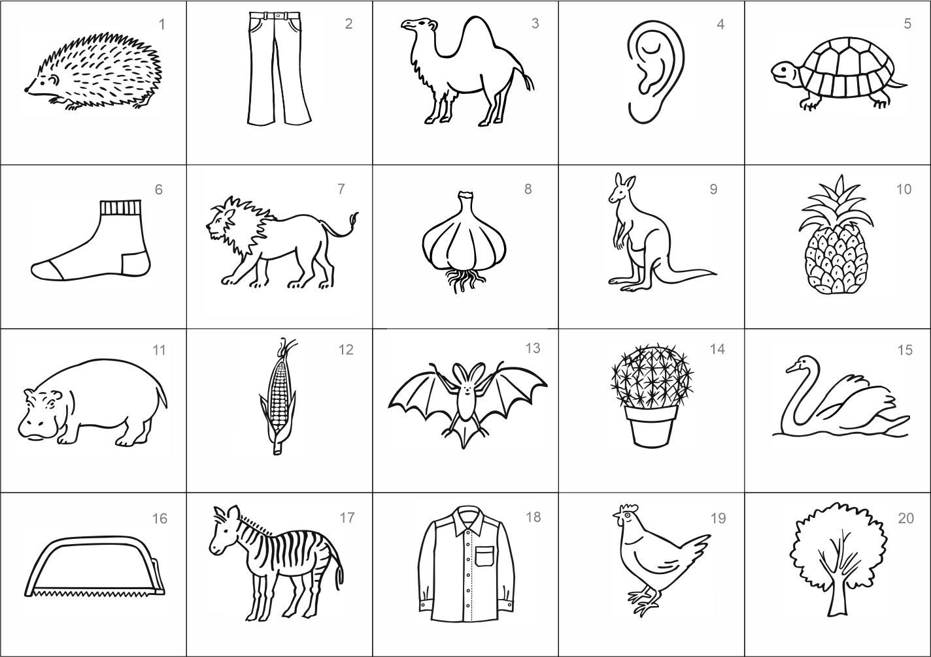

Please fold along this line -------------------------------------------------------------------------------------------

1. **Naming errors** (write down the number of errors):

A) errors include: wrong, barbled or generic term (e.g.,onion, coat, clothing)

B) correct naming include: similar name, diminutive or inferior term (e.g., linden, jeans)

* incorrect: ..……. omitted: ……......

**total number of naming ERRORS:**

norm: 0 – 1 error

2. **Total recalled picture names:** ……...

A) correct:

* incorrectly named and recalled identically or correctly (e.g.. pig – pig or pig – hippo)
* not named yet recalled (e.g. 0 – hippo)

B) subtract:

* non-existent (confabulation): –……...
* repeated (counted as one): –………

**number of CORRECTLY recalled pictures (after subtracting errors):**

norm: 6-7 pictures and more

|  |  |  |  |  |  |
| --- | --- | --- | --- | --- | --- |
| **No** | **Picture name** | **Picture number** | **No** | **Picture name** | **Picture number** |
| **1** |  |  | **9** |  |  |
| **2** |  |  | **10** |  |  |
| **3** |  |  | **11** |  |  |
| **4** |  |  | **12** |  |  |
| **5** |  |  | **13** |  |  |
| **6** |  |  | **14** |  |  |
| **7** |  |  | **15** |  |  |
| **8** |  |  | **16** |  |  |

Surname and name: …………………………………….  
Year of birth: ............... Date: ………………….  
If they use glasses, they are asked to wear them.

**Sight examination** Correct reading?: C 5 H 3

1-yes, 0-no

**Consecutive naming**: 1-systematic, 2-chaotic

**Instructions for using the hedgehog PICture Naming and Immediate Recall (PICNIR) test**

Prof. Ales Bartos, MD, PhD, Department of Neurology, Charles University Hospital, Prague, Czech Republic

**1st part Written picture naming**

**Administration:** First, the patient's eyesight is examined by reading the following 4 characters: C 5 H 3. The sheet is folded along the dashed line in the middle. Instructions are given, and it is emphasized that there are two simultaneous tasks - picture naming and memorizing. Then, the upper part of the sheet with the pictures is submitted. Picture naming is not time-limited.

**Important!** Once the naming of the pictures is finished, the folded sheet is **turned over immediately.** The examinee cannot look at the pictures anymore.

If the examinee starts naming the pictures aloud, they are asked to stop. It is necessary to maintain consistent testing conditions for all persons and prevent the facilitating effect of loud naming. This is a written task only.

If some pictures remain unnamed, you can ask the examinee a neutral question: **„Have you finished? Is that all?”** Do not specifically point to the unnamed pictures.

***INSTRUCTION: „You will see 20 pictures in a moment.”*** (Do NOT show the pictures). ***“Under each picture, write down its name in one word”*** (pause) ***“At the same time, try to remember as many pictures as you can. Later, you will be asked to write down the names of the pictures you remember.”***

**2nd part Picture recall in 1 minute**

**Administration:** The folded sheet is turned over so that the examinee can only see the lower part of the sheet WITHOUT PICTURES. The person then has up to 1 minute to write the names of all the pictures that he/she remembers. It is possible to end the test earlier by mutual agreement: “**If you cannot remember any more pictures, you can stop now.”**

**INSTRUCTION: “Now try to recall as MANY picture names as possible** (pause) **and write their names down as QUICKLY as possible** (pause) **in ANY order into this table. The order of the pictures is not important. You have one minute. Is it clear? Can we start? Now!”** After 1 minute: **“Thank you.”**

**Scoring**

**Scoring of the 1st part:** The number of naming errors is determined. There are two types of errors:  
1) pictures left unnamed (anomia) or 2) named or spelled incorrectly (semantic or phonemic paraphasias, e.g., kangaro, pinapple). These errors are marked by either circling or crossing a particular picture number.

The correct picture names are: 1. hedgehog, 2. trousers, 3. camel, 4. ear, 5. turtle, 6. sock, 7. lion, 8. garlic, 9. kangaroo / wallaby, 10. pineapple, 11. hippo / hippopotamus, 12. maize / corn, 13. bat, 14. cactus, 15. swan, 16. saw, 17. zebra, 18. shirt, 19. hen/chicken, 20. tree.

The following expressions are also acceptable: pants, jeans, dromedary, one-humped camel, tortoise, socks, river horse, deciduous tree, linden, oak, beech, ash, maple, apple tree or other species corresponding to a drawn tree. Other names are not acceptable. **This list is specific for each language and country and must be adjusted to local conditions.**

Most elderly people should make a maximum of **one naming mistake.**

**Scoring of the 2nd part:** The number of correctly recalled picture names is determined. To avoid scoring errors, either the picture number or an abbreviation of the type of the mistake is written next to each picture name. Spelling mistakes of correct objects in the picture set are counted as proper recall (e.g., kangaro, pinapple).

There are two types of errors. They are marked as follows: 1) C – confabulation: a falsely recalled name of a nonexistent picture (e.g., mole, giraffe), 2) R – repetition. The number of errors is subtracted from the total number of pictures recalled to get the number of correct answers.

Most elderly people should correctly recall **6-7 or more picture names.**