PICNIR

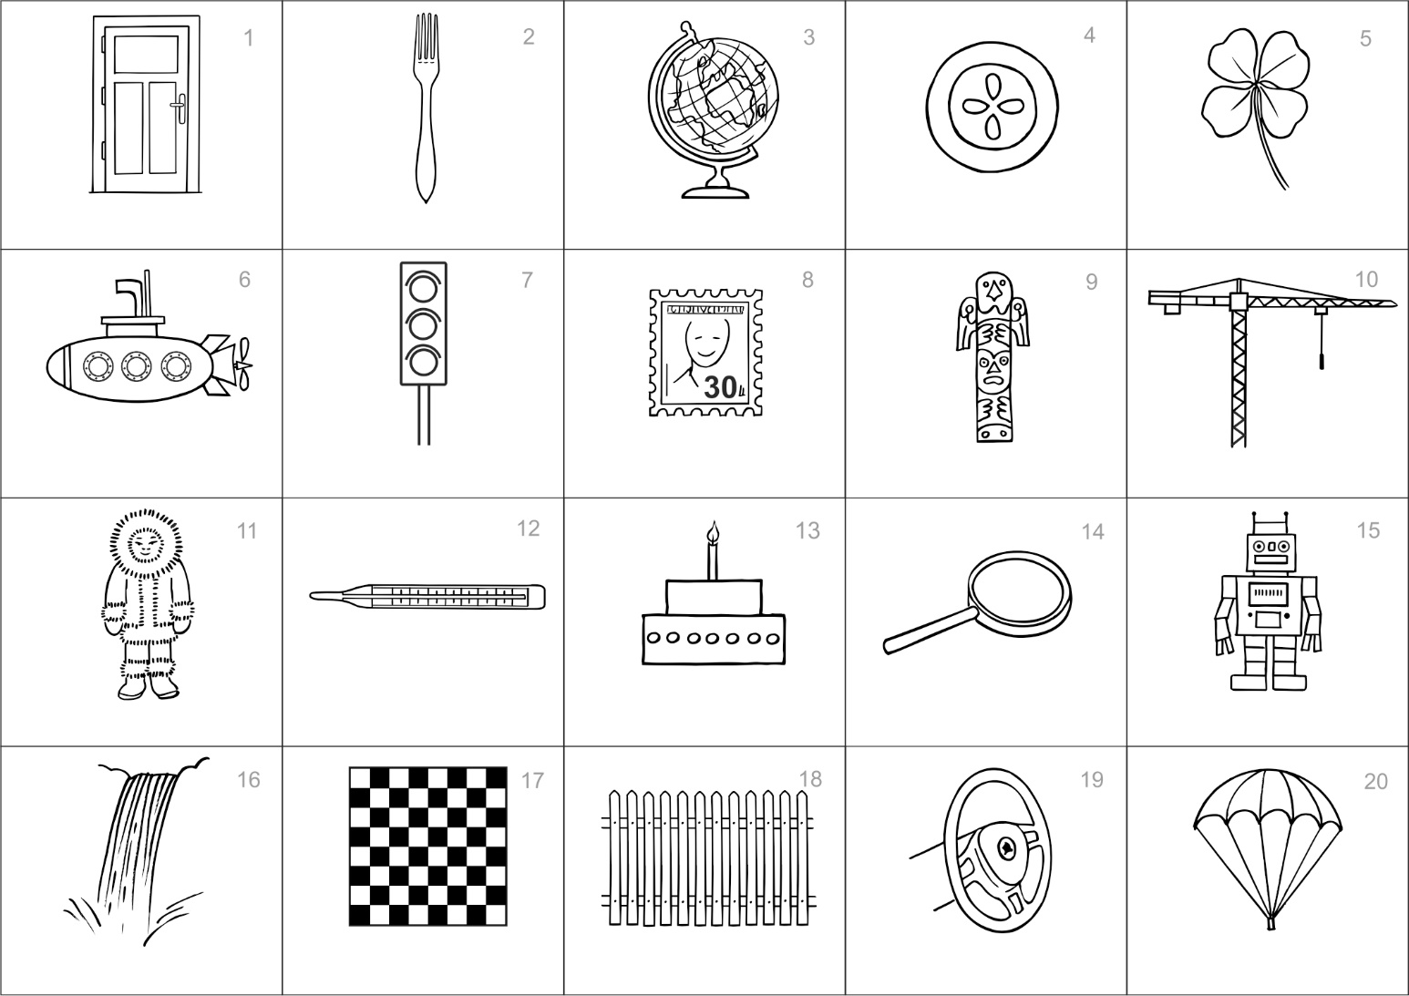

Please fold along this line -------------------------------------------------------------------------------------------

1. **Naming errors** (write down the number of errors):

A) errors include: wrong, garbled or multi-word terms without expected keyword (e.g., window, brush, globe, knob, flower, traffic lights, airship, statue, raft, chess, radiator)

B) correct naming is: if a term contains expected name (e.g., *cake* with a candle)

* incorrect: ..……. omitted: ……......

**total number of naming ERRORS:**

norm: 0 – 1 error

2. **Total recalled picture names:** ……...

A) correct:

* incorrectly named and recalled identically or correctly (e.g.. mast – mast or mast – crane)
* not named yet recalled (e.g. 0 – crane)

B) subtract:

* non-existent (confabulation): –……...
* repeated (counted as one): –………

**number of CORRECTLY recalled pictures (after subtracting errors):**

norm: 5-8 pictures and more

|  |  |  |  |  |  |
| --- | --- | --- | --- | --- | --- |
| **No** | **Picture name** | **Picture number** | **No** | **Picture name** | **Picture number** |
| **1** |  |  | **9** |  |  |
| **2** |  |  | **10** |  |  |
| **3** |  |  | **11** |  |  |
| **4** |  |  | **12** |  |  |
| **5** |  |  | **13** |  |  |
| **6** |  |  | **14** |  |  |
| **7** |  |  | **15** |  |  |
| **8** |  |  | **16** |  |  |

Surname and name: …………………………………….  
Year of birth: ............... Date: ………………….  
If they use reading glasses, have them put them on.

**Sight examination** Correct reading?: C 5 H 3

1-yes, 0-no

**Consecutive namig**: 1-systematic, 2-chaotic

RECNAM:

INSTRUCTIONS FOR USING THE **door** **PICNIR** TEST  **PIC**ture **N**aming and **I**mmediate **R**ecall

prof. Ales Bartos, MD, PhD, Department of Neurology, Charles University Hospital, Prague, Czech Republic

**1st part Written naming pictures**

**Administration:** First, the patient's eyesight is examined by reading the following 4 characters: C 5 H 3. The sheet is folded along the dashed line in the middle. Instructions are given and it is emphasized that there are two simultaneous tasks - picture naming and memorizing. Then the upper part of the sheet with the pictures is submitted. Picture naming is not time-limited.

**Important!** Once the naming of the pictures is finished, the folded sheet is **turned over immediately.** The examinee cannot look at the pictures any more.

If the examinee starts naming the pictures aloud, they are asked to stop. It is necessary to maintain consistent testing conditions for all persons and prevent the facilitating effect of loud repetition. This is a written task only.

If some pictures remain unnamed, you can ask the examinee a neutral question: **„Have you finished? Is that all?”**

***INSTRUCTION: „You will see 20 pictures in a moment.”*** (Do NOT show the pictures). ***“Under each picture, write down its name in one word”*** (pause) ***“At the same time, try to remember as many pictures as you can. Later you will be asked to write down the names of the pictures you remember.”***

**2nd part Picture recall in 1 minute**

**Administration:** The folded sheet is turned over so that the examinee can only see the lower part of the sheet WITHOUT PICTURES. The person then has up to 1 minute to write the names of all the pictures that he remembers. It is possible to end the test earlier by mutual agreement: “**If you cannot remember any more pictures, you can stop now.”**

**INSTRUCTION: “Now try to recall as MANY pictures names as possible** (pause) **and write their names down as QUICKLY as possible** (pause) **in ANY order into this table. The order of the pictures is not important. You have one minute. Is it clear? Can we start? Now!”** After 1 minute: **“Thank you.”**

**Scoring**

**Evaluation of the 1st part:** The number of naming errors is determined. There are two types of errors:  
1) pictures left unnamed (so called anomia) or 2) named or spelled incorrectly (semantic or phonemic paraphasias, e.g., window, chesbord). These errors are marked by either circling or crossing a particular picture number.

The correct answers are: 1. door, 2. fork, 3. globe, 4. pie, 5. four-leaf clover, 6. submarine, 7. traffic light, 8. stamp, 9. totem, 10. crane, 11. Eskimo, 12 thermometer, 13. cake, 14. magnifier, 15. robot, 16. waterfall, 17. chessboard, 18. fence, 19. wheel, 20. parachute.

Correct names are also **synonyms** (traffic light - lights), **multiword names** **containing expected names** (cake with candle, magnifier without glass), **sub-names** (bathyscaphe), **dialect expressions** and clover. Other names are incorrect.

Wrong names are **semantic paragraphs** (door - window, mark - painting) or **graphemic substitutions**, **missing letters and unwritten words** (globe - klobe, dor), **multiword and descriptive terms without the expected name** (magnifying glass, plate for chess), **more general names** (Northern), **approximate terms** (planks), **plural** (semaphores), and **others** (eg fork - brush, pie - button, chessboard - chess, waterfall - sluice). **Rules for correct and wrong names are specific for each language and country and has to be created accordingly.**

Most elderly people should make maximum of **0-1 mistake in naming.**

**Evaluation of the 2nd part:** The number of correctly recalled picture names are determined. To avoid scoring errors, either picture number or an abbreviation of the type of the mistake is written next to each picture name. Spelling mistakes are counted as errors.

There are two types of errors. They are marked as follows: 1) C – confabulation: a fancy name of a absent picture (e.g. key), 2) R – repetition. The number of errors is subtracted from the total number of the pictures recalled to get the number of correct answers.

Most elderly people should correctly recall **5-8 or more picture names depending on age, education,   
and gender.**

An example result of the PICNIR: 3 // 2. **RECNAM** is a single score of the PICNIR: correctly **REC**alled picture names – **NAM**ing errors, e.g., 2-3= - 1.